**Animal Face Morphing APP**

App Features:

- Admob integrated- Neat App design. - Photo selection from camera/Gallery. - Set your face for morph.- Reverse your face.- Change opacity. - Share your face morphing. - Well formed documentation. - Support 24x7 hours.

1. How to import source code :

Please follow this video

<https://www.youtube.com/watch?v=nUuFuFLQ2bE>

1. How to change admob id :

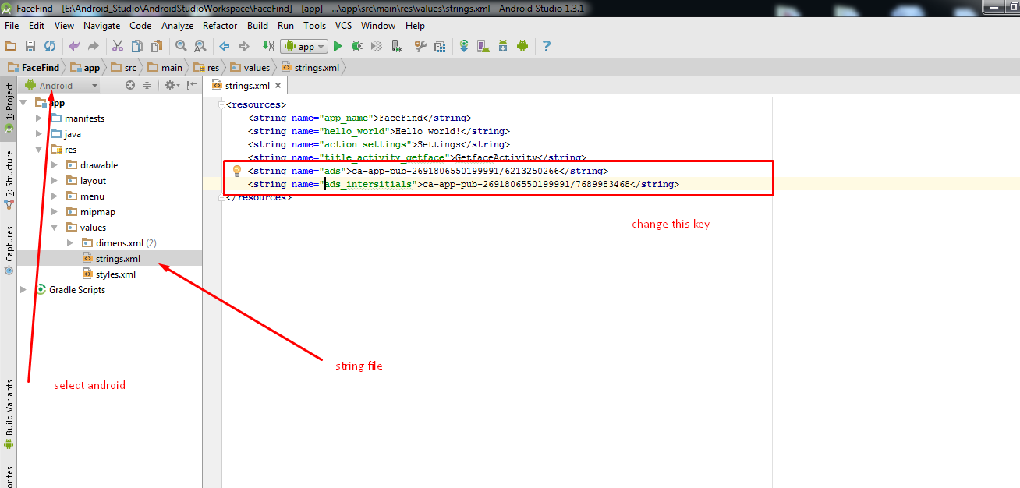

1. **How to change package name :**

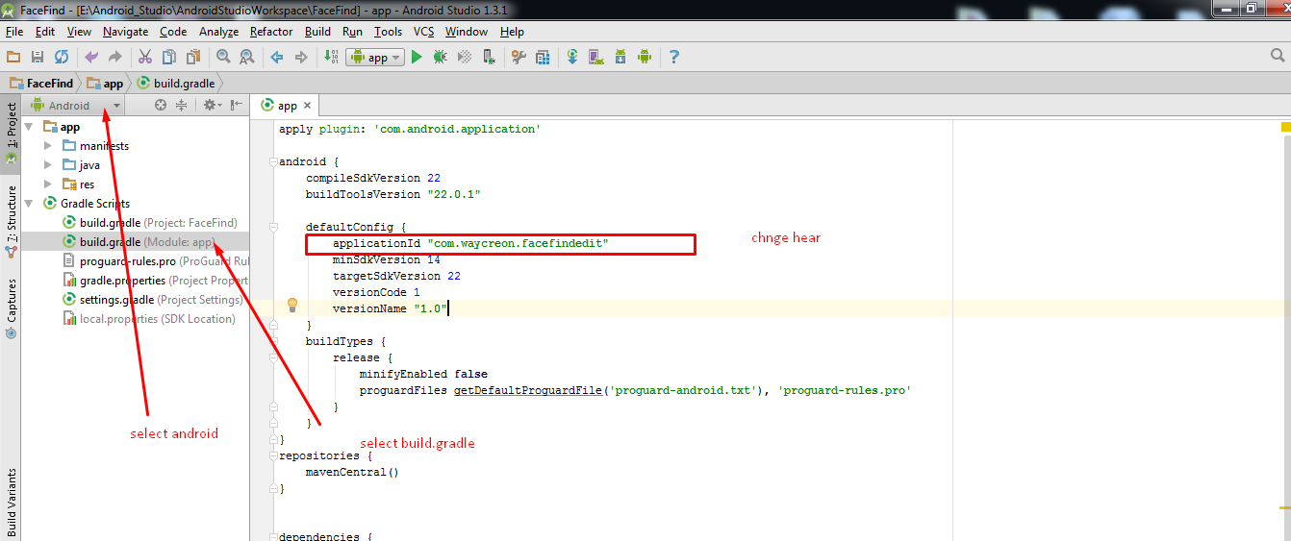

1. **How to change application name :**

Go to res > values > strings.xml

<**string name="app_name"**>FaceFind</**string**>

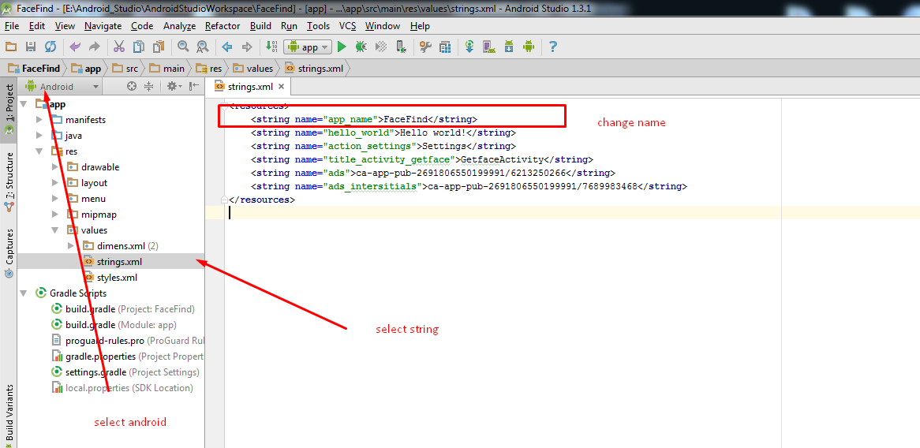

1. **How to change Graphics.**

All graphics are in res/drawable folder.

Replace or add new graphics.

Make sure image name must be same.

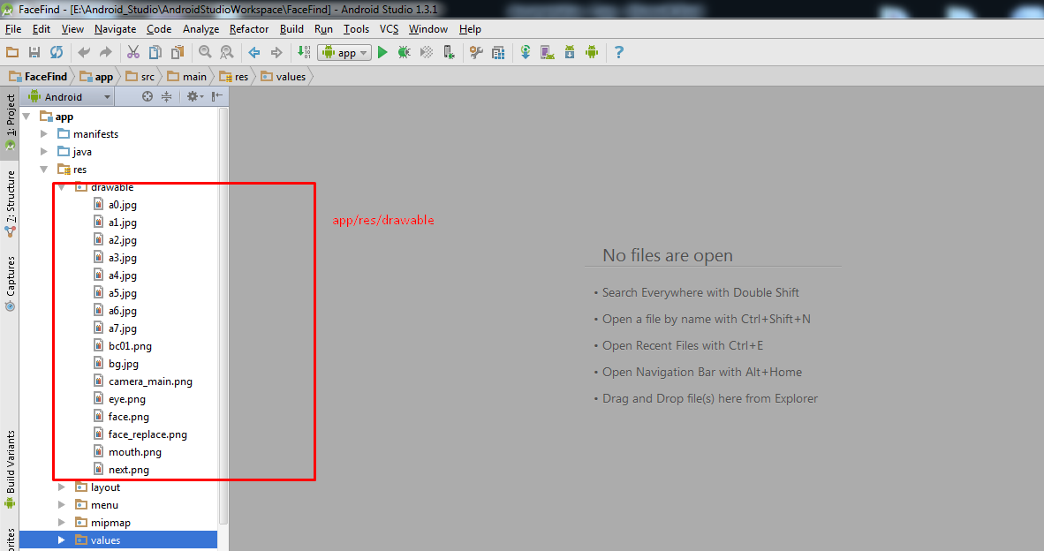

**Thank You.**